
Duik 15 Developper's guide

the complete manual of libDuik 15





This work is licensed under the Creative Commons Attribution-NonCommercial-ShareAlike 4.0 International License. To view a copy of this license, visit http://creativecommons.org/licenses/by-nc-sa/4.0/

Author: Nicolas Dufresne www.duduf.com
Composition : Assia Chioukh
Introduction
License
Including libDuik in your scripts
Installing libDuik
Using libDuik
Modifying libDuik

Pseudo Effects List

Objects
KeySpatialProperties Object
KeyFrame Object
PropertyAnim Object
MaskAnim Object
EffectAnim Object
LayerAnim Object
IKRig Object
PropertyDescription Object
Controller Object
TVPCamera
TVPCameraPoint
TVPProfileprof
TVPProfileprofPoint

Duik
Enumerated Values
Attributes
Objects
Methods
autoIK
goal
addController
addControllers
wiggle
adaptativeExposure
fixedExposure
addBones
addZeros
rotationMorph
swing
wheel
morpher
lensFlare
distanceLink
spring
copyAnim
pasteAnim
rigPaint
blink
lockProperty
scaleZLink
timeRemap
onionSkin
importRigInComp
randomizeProperties
randomizeStartTimes
randomizeInPoints
randomizeOutPoints
moveAway
groupPaint

Duik.setup
Attributes
Methods
installPseudoEffects
checkPresetEffectsVersion

Duik.ui
ScriptUI Objects
Methods

Duik.uiStrings
Attributes

Duik.settings
Attributes
Methods
save
load
restoreDefaults

Duik.bridge
Duik.bridge.tvPaint
Methods
parseCam
loadCamFile

Duik.js
Methods
escapeRegExp
replaceAll
random

Duik.utils
Methods
prepareProperty
getPropertyDimensions
getLength
getAverageSpeed
addPseudoEffect
getPuppetPins
getDistance
rigProperty
deselectLayers
checkNames
getItem
getKey
getPropertyAnims
getPropertyAnim
setPropertyAnim
addKey
getFirstKeyTime
hasSelectedKeys
convertCollectionToArray
prepIK
getControllers
getAverageSpeeds
replaceInExpressions
replaceInLayersExpressions
renameLayer
renameItem
Introduction

libDuik is a complete library of objects, attributes and methods from Duik – Duduf IK & Animation Tools for After Effects. It allows you to easily include Duik functions into other scripts.

License

Duik and libDuik are licensed under the GNU-General Public License version 3.
This means they are free software, which offers four freedoms:

- the freedom to use the software for any purpose,
- the freedom to change the software to suit your needs,
- the freedom to share the software with your friends and neighbors, and
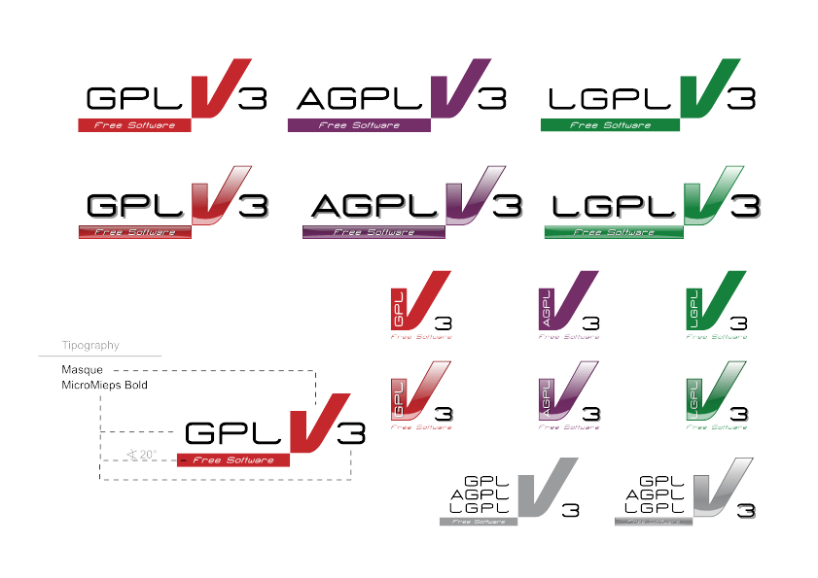
- the freedom to share the changes you make.

The complete source code along with a copy of the license of Duik and libDuik is available at:
https://github.com/Duduf-dev/Duik/

This license does not allow you to use libDuik in a non-free or commercial software. Any software using libDuik should be licensed under a free software license. See http://www.fsf.org for more information
Including libDuik in your scripts

There are three ways to use libDuik in your scripts:

• #include «libDuik.jsxinc»
Adding this line at the beginning of the script automatically loads libDuik at first run of the script. libDuik.jsxinc must be in the same folder as your script.
This is the recommended way of including libDuik.

• Copying all content of libDuik.jsxinc in the beginning of your script
Copying the whole library inside your script allows you to deploy only one file.

• Renaming libDuik.jsxinc to libDuik.jsx and move it to Scripts/Startup/
libDuik will be loaded during After Effects startup, and will then be available to all scripts. This is a good way to use Duik functions in severeal scripts without having to include libDuik in all scripts.

Installing libDuik

• Using pseudo effects
This is the default behaviour, and you should prefer to use libDuik this way.

At first launch, libDuik will automatically check if the pseudo effects it needs are already installed, and, if not, it will attempt to install them, by writing them in the file called presetEffects.xml inside the installation folder of After effects.
To achieve this, libDuik needs to be allowed to write files by After Effects. The only way to do this is for the user to check the box called « Allow scripts to write files... » in the general preferences of After Effects.

Note: You can open the preferences dialog in your scripts with:
app.executeCommand(2359);
but the user will have to check the box itself.

After the very first run of libDuik, if the pseudo effects were not already available, the user will have to restart After Effects for the pseudo effects to be loaded by After Effects.

If you want to use libDuik without allowing the scripts to write files, you can manually add the pseudo effects to presetEffects.xml: Copy/paste the content of the file Duik_presetEffects.xml distributed with libDuik, in presetEffects.xml, just before the last line « </effects> ».
Note that on Mac OS you will have to change the file permissions to be able to modify it.

• Using presets
If you cannot modify presetEffects.xml, or for any other reason, you can use .ffx presets.
You just have to set Duik.usePresets to true.

Note: if libDuik was not able to update presetEffects.xml, it will default Duik.usePresets to true. If presetEffects.xml is up-to-date, Duik.usePresets will be false by default.
By default, libDuik will look for .ffx files inside its own folder. You can specify another folder by setting the path to Duik.presetPath with an ending « / ».
The .ffx files must be named by the corresponding pseudo effects matchNames plus the extension (.ffx). A complete list of those matchNames is available in this document.

Note: if presetEffects.xml is not updated with libDuik pseudo effects, when using presets After Effects may warn for missing effects. libDuik will work well anyway.

Note: the presets distributed with libDuik are CC2014 versions (for this beta version of libDuik. Later versions may be distributed with CS6, or even CS4 versions of presets). Sadly, After Effects presets cannot be used with older versions of After Effects than the one used to create them. If you need to use presets with older versions, you will have to create your own.

Using libDuik

Once libDuik has been loaded, all its classes, attributes and methods are available in the javascript object Duik, for all scripts run by After Effects.

libDuik is loaded only once; this allows a faster launch of your scripts.

Modifying libDuik

If you're modifying libDuik and need to test it without having to reboot After Effects to reload it, you can un-comment the first line:
if (typeof Duik === 'object') delete Duik;
inside libDuik itself, or you can include this line in your own script before #include libDuik;
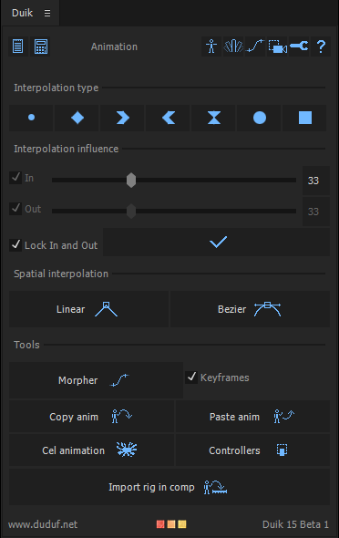
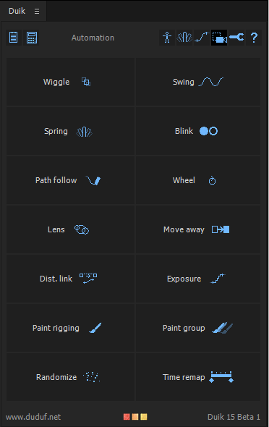
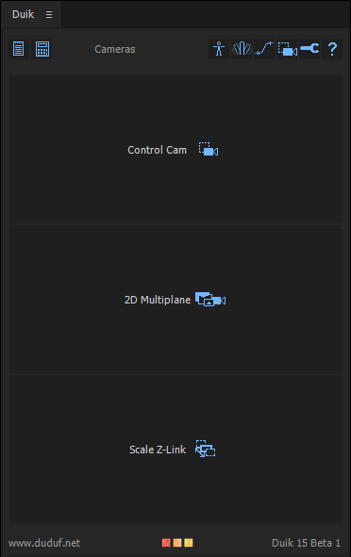
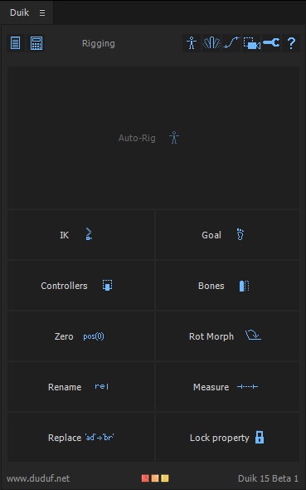
Pseudo Effects List

libDuik uses pseudo effects instead of expression controls. Those effects must be added to presetEffects.xml (see Introduction, Installing libDuik for more details).
The XML code used to create those effects is Duik_presetEffects.xml

Here is a list of the effects available.

Those effects can be added on any layer with:
layer.effect.addProperty(matchName)
Example:
app.project.activeItem.layer(1).effect.addProperty('DUIK_One_Layer_IK');

matchName | Description | Screenshot
DUIK_One_Layer_IK | Used by one layer IK | 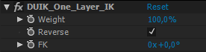
DUIK_Two_Layer_IK | Used by two layer IK | 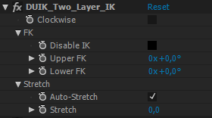
DUIK_Three_Layer_IK | Used by three layer IK | 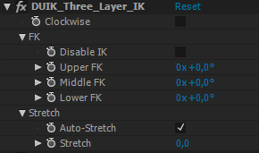
DUIK_3D_Wiggle | Used for wiggle on 3D properties | 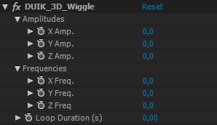
DUIK_2D_Wiggle | Used by wiggle on 2D properties | 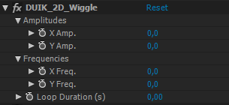
DUIK_1D_Wiggle | Used by wiggle on 1D properties | 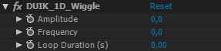
DUIK_Exposure | Used by exposure, in fixed mode | 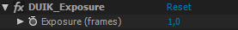
DUIK_RotMorph | Used by Rotation Morph | 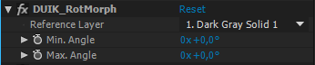
DUIK_Swing | Used by Swing (oscillation) | 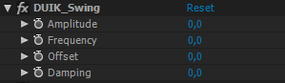
DUIK_Wheel | Used by Wheel | 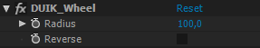
DUIK_LensFlare | Used by Lens Flare on the layer of the center to control size and intensity | 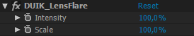
DUIK_LensFlareDistance | Used by Lens Flare on flare layers to control their distance from the center | 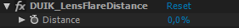
DUIK_DistanceLink | Used by Distance Link | 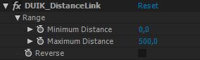
DUIK_Spring | Used by Spring on 2D and 3D properties | 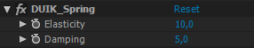
DUIK_Spring_Bounce | Used by spring on 1D properties, includes a checkbox called 'bounce'. | 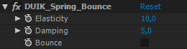
DUIK_Paint_Rig | Used by the paint rig tool to control the end, begin and diameter properties of the paint brushes | 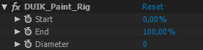
DUIK_Blink_1D | Used by blink on 1D properties | 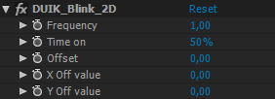
DUIK_Blink_2D | Used by blink on 2D properties | 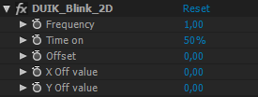
DUIK_Blink_3D | Used by blink on 3D properties | 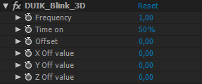
DUIK_Multiplane | Used by 2D Multiplane cam | 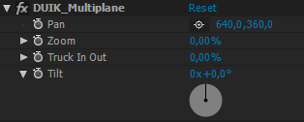
DUIK_Paint_Group | Used by Paint groups | 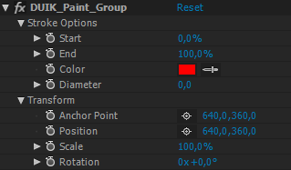

Objects

libDuik creates new javascript instantiable javascript objects, which can be very helpful when working with After Effects, and are needed by Duik.

Name | Description
KeySpatialProperties | Describes all spatial properties of a KeyFrame.
KeyFrame | Represents an animation keyframe of After Effects
PropertyAnim | Describes the keyframe animation of a given property
MaskAnim | Describes all the keyframe animations of the properties of a given Mask
EffectAnim | Describes all the keyframe animations of the properties of a given Effect
LayerAnim | Describes all the keyframe animations of the transformation, masks, and effects of a layer
IKRig | Describes an IK created by Duik (layers needed, type, goal, controller...)
PropertyDescription | Describes any property (useful to retrieve a property if the selection changes in the effects)
Controller | A controller created by Duik
TVPCamera | A camera imported from TVPaint
TVPCameraPoint | A spatial keyframe of a camera from TVPaint
TVPProfileprof | Temporal interpolation from TVPaint
TVPProfileprofPoint | A temporal keyframe from TVPaint

KeySpatialProperties object attributes

Describes all spatial properties of a KeyFrame.

KeySpatialProperties.inTangent
KeySpatialProperties.outTangent
KeySpatialProperties.continuous
KeySpatialProperties.autoBezier
KeySpatialProperties.roving

Name | Type | Description
inTangent | float or Array of float | In spatial tangent of the keyframe
outTangent | float or Array of float | Out spatial tangent of the keyframe
continuous | boolean | Spatial interpolation set to continuous
autoBezier | boolean | Spatial interpolation set to auto Bezier
roving | boolean | Keyframe set to roving

KeyFrame object attributes

Represents an animation keyframe of After Effects
See Duik.utils.getKey() and Duik.utils.addKey()

KeyFrame.time
KeyFrame.value
KeyFrame.inInterpolationType
KeyFrame.outInterpolationType
KeyFrame.spatial
KeyFrame.spatialProperties
KeyFrame.inEase
KeyFrame.outEase
KeyFrame.continuous
KeyFrame.autoBezier

Name | Type | Description
time | float | Time of the keyframe in the comp
value | Any AFX propertyValueType | Value of the keyframe
inInterpolationType | Enumerated value; one of:  KeyframeInterpolationType.LINEAR  KeyframeInterpolationType.BEZIER  KeyframeInterpolationType.HOLD | In interpolation type of the keyframe
outInterpolationType | Enumerated value; one of:  KeyframeInterpolationType.LINEAR  KeyframeInterpolationType.BEZIER  KeyframeInterpolationType.HOLD | Out interpolation type of the keyframe
spatial | boolean | True if the keyframe is on a spatial property, one of:  PropertyValueType.ThreeD_SPATIAL  PropertyValueType.TwoD_SPATIAL
spatialProperties | KeySpatialProperties | All spatial properties of the keyframe. See KeySpatialProperties object attributes
inEase | Array of AFX KeyframeEase objects | Incoming temporal ease of the keyframe
outEase | Array of AFX KeyframeEase objects | Outgoing temporal ease of the keyframe
continuous | boolean | Temporal interpolation set to continuous

PropertyAnim object attributes

Describes the keyframe animation of a given property
See Duik.utils.getPropertyAnim() and See Duik.utils.setPropertyAnim()

PropertyAnim.name
PropertyAnim.keys
PropertyAnim.startValue

Name | Type | Description
name | string | Name of the animated Property
keys | Array of KeyFrames | Keyframes of the animation, see KeyFrame object attributes
startValue | Any AFX propertyValueType | First value of the animation. If there's no keyframe PropertyAnim.keys.length == 0, the value of the property.

MaskAnim object attributes

Describes all the keyframe animations of the properties of a given Mask
See Duik.utils.getPropertyAnims()

MaskAnim.name
MaskAnim.anims

Name | Type | Description
name | string | Name of the animated Mask
anims | Array of PropertyAnim | Animations of the properties of the mask, see PropertyAnim object attributes

EffectAnim object attributes

Describes all the keyframe animations of the properties of a given Effect
See Duik.utils.getPropertyAnims()

EffectAnim.name
EffectAnim.matchName
EffectAnim.anims

Name | Type | Description
name | string | Name of the animated Effect
matchName | string | matchName of the animated Effect
anims | Array of PropertyAnim | Animations of the properties of the effect, see PropertyAnim object attributes

LayerAnim object attributes

Describes all the keyframe animations of the transformation, masks, and effects of a layer
See Duik.copyAnim() and Duik.pasteAnim()

LayerAnim.name
LayerAnim.index
LayerAnim.transformAnims
LayerAnim.effectsAnims
LayerAnim.masksAnims

Name | Type | Description
name | string | Name of the animated layer
index | string | Index of the animated layer
transformAnims | Array of PropertyAnim | Animations of the transformations, see PropertyAnim object attributes
effectsAnims | Array of EffectAnim | Animations of the effects, see EffectAnim object attributes
masksAnims | Array of MaskAnim | Animations of the masks, see MaskAnim object attributes

IKRig object attributes

Describe an IK created by Duik.

IKRig.type
IKRig.layer1
IKRig.layer2
IKRig.layer3
IKRig.goal
IKRig.controller
IKRig.threeD
IKRig.frontFacing
IKRig.clockWise
IKRig.created

Name | Type | Description
type | int | Type of the IK, either 1, 2, or 3.  0 if the IK is not valid.
layer1 | AVLayer | First layer of the IK (the root, the top parent)
layer2 | AVLayer or null | The second layer of the IK, if type is 2 or 3, or null if type is 1.
layer3 | AVLayer or null | The third layer of the IK, if type is 3, or null if type is 1 or 2.
goal | AVLayer or null | A goal layer attached to the IK, or null
controller | AVLayer | The controller layer of the IK
threeD | boolean | true if this is a 3D IK (used for type 2 only)
frontFacing | boolean | true if the 3D layers face the front/back views, false if they face the right/left views.
clockWise | boolean | true if the IK bends clockwise. Used with type 2 and 3 only.
created | boolean | true if the IK has already been successfully created and exists in the comp.

IKRig object methods

IKRig.create()

Name | Description | Return
create() | Creates the rig in the comp | AVLayer, the zero created (if any) or null

IKRig.create()

Creates the IK Rig in the comp. Sets the created attribute to true if sucessful.

returns

AVLayer, the zero created (if any) or null.

PropertyDescription object attributes

Describes any property (useful to retrieve a property if the selection changes in the effects)

PropertyDescription.isEffect
PropertyDescription.index
PropertyDescription.depth
PropertyDescription.parentName
PropertyDescription.dimensions
PropertyDescription.canSetExpression

Name | Type | Description
isEffect | boolean | Property.parentProperty.isEffect
index | integer | Property.propertyIndex
depth | integer | Property.propertyDepth
parentName | string | Property.parentProperty.name
dimensions | integer | 1, 2 or 3
canSetExpression | boolean | Property.canSetExpression

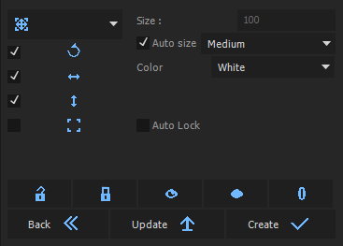
Controller object attributes

A controller created by Duik, which can have several shapes.

There are four transform shapes which can be combined:


And three special shapes:

Controller.locked
Controller.xPosition
Controller.yPosition
Controller.rotation
Controller.scale
Controller.arc
Controller.eye
Controller.layer
Controller.size
Controller.type
Controller.color

Name | Type | Description | Screenshot
locked | boolean | If true, transformation properties not controlled by the controller are locked with a simple expression, to prevent inadvertantly changing them
xPosition | boolean | If true, the X Position of the controller may be animated | 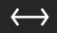
yPosition | boolean | If true, the Y Position of the controller may be animated | 
rotation | boolean | If true, the Rotation of the controller may be animated | 
scale | boolean | If true, the Scale of the controller may be animated | 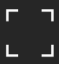
arc | boolean | If true, the Rotation of the controller may be animated. The controller is displayed differently than with Controller.rotation, because its anchor point may be moved. | 
eye | boolean | If true, the Position of the controller may be animated. The icon is an eye. | 
camera | boolean | If true, the Position and rotation of the controller may be animated. The icon is a camera. | 
layer | ShapeLayer | The controller layer
size | float | The size of the controller (in % if type is VECTOR, pixels if type is NULL)  Set to 0 to use Duik.settings.controllerSize
type | integer | Enumerated value, one of:  Duik.layerTypes.NULL  Duik.layerTypes.VECTOR
color | Array of floats [R,V,B,A] | The color of the controller

Controller object methods

Controller.lock()
Controller.unlock()
Controller.update()

Name | Description | Return
lock() | Locks the transformation properties not controlled by the controller, to prevent inadvertantly changing them | void
unlock() | Unlocks the previously locked transformation properties. Note that before parenting a controller, it should be unlocked. | void
update() | Updates the shape of the controller, if its properties have changed | void

TVPCamera object attributes

Describes a Camera imported from TVPaint

TVPCamera.points
TVPCamera.pointCount
TVPCamera.profileprof

Name | Type | Description
points | Array of TVPCameraPoint | The spatial keyframes of the camera animation
pointCount | integer | The number of spatial points of the camera
profileprof | TVPProfileprof | The temporal interpolation of the camera

TVPCamera object methods

TVPCamera.createNull(comp, links)
TVPCamera.precompose(comp)
TVPCamera.applyToLayer(camLayer, links)

Name | Description | Return
createNull(comp, links) | Creates a Null object representing the TVPaint Camera in the comp | void
precompose(comp) | Precomposes all layers of the comp, and animates the resulting layer with the animation of the camera | void
applyToLayer(camLayer, links) | Applies the animation of the camera to the given layer | void

TVPCameraPoint object attributes

A spatial keyframe of a camera from TVPaint

TVPCameraPoint.x
TVPCameraPoint.y
TVPCameraPoint.zoom
TVPCameraPoint.rotation

Name | Type | Description
x | float | X position
y | float | Y position
zoom | float | Zoom value (from 0.0 to 1.0 or more)
rotation | float | Rotation (degrees)

TVPProfileprof object attributes

A temporal interpolation from TVPaint

TVPProfileprof.points
TVPProfileprof.linear
TVPProfileprof.pointCount

Name | Type | Description
points | Array of TVPProfileprofPoint | Temporal keyframes
linear | boolean | Wether interpolation is linear or bezier
pointCount | integer | Number of temporal keyframes

TVPProfileprofPoint object attributes

A temporal keyframe from TVPaint

TVPProfileprofPoint.u
TVPProfileprofPoint.v

Name | Type | Description
u | float | Time coordinate of the key (from 0.0 to 1.0, 1.0 representing the end of the animation)
v | float | Value coordinate of the key (from 0.0 to 1.0, 1.0 representing the value of the last spatial point.

Duik

Duik Enumerated Values

Duik uses some predefined values to be simpler to use. Here are those values you can use with Duik settings, methods and attributes:

Name | Type | Value
Duik.sizes.SMALL | integer | 0
Duik.sizes.MEDIUM | integer | 1
Duik.sizes.BIG | integer | 2
Duik.layerTypes.VECTOR | integer | 2
Duik.layerTypes.NULL | integer | 1
Duik.layerTypes.SOLID | integer | 0
Duik.getLayers.INDEX | integer | 0
Duik.getLayers.NAME | integer | 1
Duik.getLayers.SELECTION_INDEX | integer | 2
Duik.placement.TOP | integer | 0
Duik.placement.BOTTOM | integer | 1
Duik.placement.OVER_LAYER | integer | 2
Duik.placement.UNDER_LAYER | integer | 3
Duik.colors.WHITE | Array of floats | [1,1,1,1]
Duik.colors.RED | Array of floats | [1,0,0,1]
Duik.colors.GREEN | Array of floats | [0,1,0,1]
Duik.colors.BLUE | Array of floats | [0,0,1,1]
Duik.colors.CYAN | Array of floats | [0,1,1,1]
Duik.colors.MAGENTA | Array of floats | [1,0,1,1]
Duik.colors.YELLOW | Array of floats | [1,1,0,1]
Duik.colors.BLACK | Array of floats | [0,0,0,1]
Duik.colors.LIGHT_GRAY | Array of floats | [0.75,0.75,0.75,1]
Duik.colors.DARK_GRAY | Array of floats | [0.25,0.25,0.25,1]

Duik Attributes

string Duik.version
float Duik.versionNumber
boolean Duik.forceReload
boolean Duik.usePresets
string Duik.presetPath
float Duik.presetEffectsInstalledVersion

Name | Type | Description
version | string, read-only | Version string of libDuik
versionNumber | float, read-only | Version number of libDuik
usePresets | boolean | true to use presets instead of pseudo effects.
presetPath | string | Path where presets are located; By default, the path of libDuik.jsxinc itself.
presetEffectsInstalledVersion | float, read-only | Version number of installed pseudo effects. Should be the same of Duik.versionNumber
copiedAnim | Array of LayerAnim | The layer animations copied with Duik.copyAnim() method.

Duik Objects

Duik.uiString
Duik.settings
Duik.utils
Duik.setup
Duik.js
Duik.bridge

Name | Description
uiStrings | Contains all string names used by effects created by Duik.  You can set these strings to translate libDuik at runtime.  Default values are English names.
settings | Access to settings used by Duik.
utils | Some useful tools
setup | Methods and attributes to correctly install libDuik & pseudo effects.
bridge | Import / Export tools
js | General javascript tools

Duik Methods

//TODO tri par ordre alphabétique

Low-level methods are listed below (greyed) but they are not documented.
If you do not understand what low-level methods do by reading them in libDuik.jsxinc, you shouldn't need them.

Duik.autoIK(layers, clockWise, frontFacing)
Duik.goal(layer, controller)
Duik.addController(layer,color,rotation,xPosition,yPosition,scale,arc)
Duik.addControllers(layers,color,rotation,xPosition,yPosition,scale,arc)
Duik.oneLayerIK(controller,layer)
Duik.twoLayerIK(controller,root,end,clockWise,frontFacing)
Duik.threeLayerIK(controller,root,middle,end,clockWise)
Duik.wiggle(layer,property,separateDimensions)
Duik.threeDWiggle(layer,property,)
Duik.twoDWiggle(layer,property)
Duik.oneDWiggle(layer,property)
Duik.adaptativeExposure(layer,property,precision,minExp,maxExp)
Duik.fixedExposure(layer,property)
Duik.addBones(layers)
Duik.addZero(layer)
Duik.addZeros(layers)
Duik.rotationMorph(layer,prop)
Duik.swing(layer,prop)
Duik.wheel(layer,radius,curved)
Duik.morpher(layers)
Duik.lensFlare(layers)
Duik.distanceLink(layer, property, parentLayer)
Duik.spring(property, layer, simulated)
Duik.copyAnim(layers, selectedKeysOnly, startTime, endTime)
Duik.pasteAnim(layers, layerAnims, startTime, getLayerMethod)
Duik.rigPaint(layers)
Duik.blink(layer,prop)
Duik.lockProperty(layer, prop)
Duik.scaleZLink(layers)
Duik.timeRemap(layers)
Duik.onionSkin(layer,activate,duration)
Duik.importRigInComp(comp,rigComp,rigName)
Duik.randomizeProperties(props,fromCurrentVal,xMin,xMax,yMin,yMax,zMin,zMax)
Duik.randomizeStartTimes(layers,fromCurrentVal,min,max)
Duik.randomizeInPoints(layers,fromCurrentVal,min,max)
Duik.randomizeOutPoints(layers,fromCurrentVal,min,max)
Duik.pathFollow(layer)
Duik.multiplane(numLayers)
Duik.moveAway(layer)
Duik.groupPaint(props)

Name | Description | Return | Screenshot from Duik
autoIK(layers, clockWise, frontFacing) | Adds IK on the layers | true if successful, false if anything went wrong | 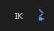
goal(layer, controller) | Adds a goal effect to the layer, which may be controlled by a controller | true if successful, false if anything went wrong | 
addController(layer, autoLock, rotation, xPosition, yPosition, scale) | Creates a null object (controller) at layer position and named by layer.name | Controller object
addControllers(layers, autoLock, rotation, xPosition, yPosition, scale) | For each layer,  Creates a null object (controller) at layer position and named by layer.name | Array of Controller objects | 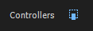
wiggle(layer, property, separateDimensions) | Adds a wiggle effect to given property | true if successful, false if anything went wrong | 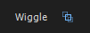
adaptativeExposure(layers, precision, minExp, maxExp, sync, layerSync) | Adds exposure controls to the animation of the property. | true if successful, false if anything went wrong | 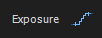
fixedExposure(layer, prop) | Adds exposure controls to the animation of the property. | true if successful, false if anything went wrong
addBones(layers) | Adds bones to the layers | Array of AVLayer;  bones | 
addZero(layer) | Adds zero to the layer | AVLayer; zero
addZeros(layers) | Adds zeros to the layers | Array of AVLayer;  zeros | 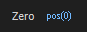
rotationMorph(layer, prop) | Creates a rotation morph on the given property | true if successful, false if anything went wrong | 
swing(layer,prop) | Creates a swing on the given property | true if successful, false if anything went wrong | 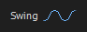
wheel(layer, radius, curved) | Automates the rotation of the given layer using its position | true if successful, false if anything went wrong | 
morpher(layers) | Adds a slider to easily control interpolations of selected properties of the given layers. | true if successful, false if anything went wrong
lensFlare(layers) | Rigs the layers to move like a lens flare. | true if successful, false if anything went wrong | 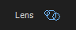
distanceLink(layer, property, parentLayer) | Links the property to the distance of parentLayer | true if successful, false if anything went wrong | 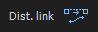
spring(property, layer, simulated) | Adds a spring effect on the properties | true if successful, false if anything went wrong | 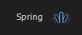
copyAnim(layers, selectedKeysOnly, startTime, endTime) | Copies the animation of the layers | Array of LayerAnim
pasteAnim(layers, layerAnims, startTime, getLayerMethod) | Pastes the animations on the layers | int, the number of the layers on whichh an animtion was pasted
rigPaint(layers) | Rigs the paint effects to be able to animate all strokes as if there was only one. | Void | 
blink(layer, prop) | Adds a blink effect to the property. | true if successful, false if anything went wrong
lockProperty(layer, prop) | Locks the property with a simple expression. | void | 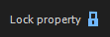
scaleZLink(layers) | Links the distance of the layer from the camera to its scale so its apparent size won't change. | void | 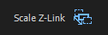
timeRemap(layers) | Activates the time remapping of the layers, extending them to the length of the comp and adjusting the last keyframe. | Void | 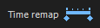
onionSkin(layer, activate, duration) | Activates or deactivates an onion skin on the paint effects of the layer. | void | 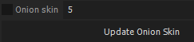
importRigInComp(comp,rigComp, rigName) | Imports a rig in the current comp (taking care of duplicates, expressions, controllers and adding a Master Controller to move, scale & flip the rig. | Void
randomizeProperties(props, fromCurrentVal, xMin, xMax, yMin, yMax, zMin, zMax) | Randomizes the values of the properties. | void | 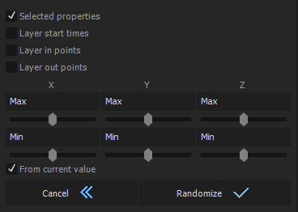
randomizeStartTimes(layers, fromCurrentVal, min, max) | Randomizes start times of the given layers. | void
randomizeInPoints(layers, fromCurrentVal, min, max) | Randomizes in points of the given layers. | void
randomizeOutPoints(layers, fromCurrentVal, min, max) | Randomizes out points of the given layers. | Void
pathFollow(layer) | Rigs the rotation of a layer so it follows its path | Void | 
multiplane(numLayers) | Creates null objects rigged to easily animate a 2D multiplane camera. | void | 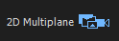
moveAway(layer) | Rigs the layer to be able to move it away from its parent with a simple slider | void | 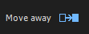
groupPaint(props) | Rigs the paint effects to be able to animate all brushes as if there was only one. | void

Duik.autoIK(layers, clockWise, frontFacing)

Adds IK on the layers. Duik will attempt to autodetect each layer role, using Duik.utils.prepIK(). If it can't (wrong parenting, wrong placement...) it will use the order of the layers in the Array or LayerCollection: first the layers, from end to root (from child to parent), last the controller.

parameters:

layers | Array of AVLayers or LayerCollection
clockWise | boolean, used only with two-layer and three-layer IK, default: false
frontFacing | boolean, default: false

returns

IKRig object created

Duik.goal(layer, controller)

Adds a goal effect to the layer, which may be controlled by a controller

parameters:

layer | AVLayer
controller | AVLayer or undefined

returns

true if successful, false if anything went wrong

Duik.addController(layer, autoLock, rotation, xPosition, yPosition, scale)

Creates a null object (controller) at layer position and named by layer.name
If Duik.settings.controllerType is Duik.layerTypes.VECTOR, the parameters are used to draw a nice icon instead of using a null object.
If autoLock is true, the transformations which should not be changed are locked with a simple expression.
See Controller object.

parameters

layer | AVLayer
autoLock | boolean, default false
rotation | boolean, default true
xPosition | boolean, default true
yPosition | boolean, default true
scale | boolean, default false

returns

Controller object

Duik.addControllers(layers, autoLock, rotation, xPosition, yPosition, scale)

This is a convenience method, which runs Duik.addController() on each layer of the given array of layers.

parameters

layers | Array of AVLayer or LayerCollection
color | Array of 4 floats : [R,V,B,A], default [1,1,1,1]
autoLock | boolean, default false
rotation | boolean, default true
xPosition | boolean, default true
yPosition | boolean, default true
scale | boolean, default false
arc | boolean, default false

returns

Array of Controller objects

Duik.wiggle(layer, property, separateDimensions)

Adds a wiggle effect to given property.

parameters

layer | AVLayer of the property
property | Property
separateDimensions | boolean, false to apply the same wiggle to all dimensions, default: false

returns

true if successful, false if anything went wrong

Duik.fixedExposure(layer,prop)

Adds exposure controls to the animation of the property.

parameters

layer | AVLayer
prop | Property

returns

true if successful, false if anything went wrong

Duik.adaptativeExposure(layers,precision,minExp,maxExp,sync,layerSync)

Adds exposure controls to the animation of the property. The exposure adapts automatically to the speed, according to the given precision, of the properties between a minimum and a maximum exposure (in frames).

parameters

layers | Array of AVLayer or LayerCollection
precision | integer, default: 100
minExp | integer, default: 1
maxExp | integer, default: 4
sync | boolean, wether to sync all properties, default: true
layerSync | boolean, wether to sync all layers, if sync == true, default: false

returns

true if successful, false if anything went wrong

Duik.addBones(layers)

Adds bones to the layers, only on selected pins if any, or else on all puppet pins found on those layers.

parameters

layers | Array of AVLayers

returns

Array of AVLayers, the bones created

Duik.addZero(layer)

Adds a null object for the layer, at the same place and orientation, and then parents the layer to it, parenting the null object (the zero) to the former parent of the layer.

parameters

layers | Array of AVLayers

returns

Array of AVLayers, the zeros created

Duik.addZeros(layers)

This is a convenience method, which runs Duik.addZero() on each layer of the given array of layers.

parameters

layers | Array of AVLayers or LayerCollection

returns

Array of AVLayers, the zeros created

Duik.rotationMorph(layer,prop)

Creates a rotation morph on the given property.

Parameters

layer | AVLayer
prop | Property

returns

true if successful, false if anything went wrong

Duik.swing(layer,prop)

Creates a swing on the given property

parameters

layer | AVLayer
prop | Property

returns

true if successful, false if anything went wrong

Duik.wheel(layer, radius, curved)

Automates the rotation of the given layer using its position.
If curved, works even if the trajectory is not horizontal, but is heavier to compute.

parameters

layer | AVLayer
radius | float, default 100.0
curved | boolean, default false

returns

true if successful, false if anything went wrong

Duik.morpher(layers)

Adds a "morpher", a slider to easily control interpolations of selected properties of the given layers.

parameters

layers | Array of AVLayer

returns

true if successful, false if anything went wrong

Duik.lensFlare(layers);

Rigs the layers to move like a lens flare. The first layer in the selection is the controller, with sliders for intensity and size; the other layers have a distance property to adjust their position along the lens flare.

parameters

layers | Array of AVLayer

returns

true if successful, false if anything went wrong

Duik.distanceLink(layer,property,parentLayer);

Links the property to the distance of parentLayer

parameters

layer | AVLayer containing the property
property | Property to rig
parentLayer | AVLayer which distance from layer is used to rig

returns

true if successful, false if anything went wrong

Duik.spring(property, layer, simulated);

Adds a spring effect on the property

parameters

property | Property
layer | AVLayer containing the property
simulated | if true, applies the simulated version of the spring, default: false

returns

true if successful, false if anything went wrong

Duik.copyAnim(layers, selectedKeysOnly, startTime, endTime)

Copies all the animations as LayerAnim objects (except expressions) on selected layers, and store them in the Array Duik.copiedAnim.
If selectedKeysOnly is true, copies only the selected keyframes, otherwise all the masks, effcts, and transformation properties will be copied, even if they are not animated (in this case, the value will be stored in the PropertyAnim.startValue). If you do not want to keep the properties without animation, you will have to loop through the arrays of PropertyAnim and check if PropertyAnim.keys.length > 0 to remove empty animations from the Arrays.
See LayerAnim object

parameters

layers | Array or Collection of AVLayers
selectedKeysOnly | boolean, true to copy only selected keys, default: false
startTime | float, default: start of the comp
endTime | float, default: end of the comp

returns

Array of LayerAnim

Duik.pasteAnim(layers, layerAnims, startTime, getLayerMethod)

Pastes all the animations in the Array of LayerAnim on layers, using layer names or layer indexes, beginning at startTime
See LayerAnim object

parameters

layers | Layers where to paste the animation
layerAnims | Array of LayerAnim, default: Duik.copiedAnim
startTime | float, default: comp.time
getLayerMethod | one of Duik.getLayers.NAME, Duik.getLayers.INDEX, Duik.getLayers.SELECTION_INDEX, default: Duik.settings.getLayerMethod

returns

integer, number of layers on which animations were pasted

Duik.rigPaint(layers)

Rigs the paint effects to be able to animate all strokes as if there was only one.

parameters

layers | Array of AVLayers or LayerCollection

returns

void

Duik.blink(layer, prop)

Adds a blink effect to the property.

parameters

layer | AVLayer
prop | Property

returns

true if successful, false if anything went wrong

Duik.lockProperty(layer, prop)

Locks the property with a simple expression.

parameters

layer | AVLayer
prop | Property

returns

void

Duik.scaleZLink (layers)

Links the distance of the layer from the camera to its scale so its apparent size won't change. If multiple cameras, include the camera used in the array.

parameters

layers | Array of Layer or LayerCollection

returns

void

Duik.timeRemap(layers)

Activates the time remapping of the layers, extending them to the length of the comp and adjusting the last keyframe.

parameters

layers | Array of Layer or LayerCollection
loopType | String, "in" or "out" or "none", default: "none"

returns

void

Duik.onionSkin(layers)

Activates or deactivates an onion skin on paint effects on the layer.

parameters

layer | AVLayer
activate | boolean, default: true
duration | integer, onion skin duration in frames, default: 5

returns

void

Duik.importRigInComp(comp, rigComp, rigName, progressBar, progressText, containingWindow)

Imports a rig in the comp, transferring and linking the controllers in the new comp, while keeping the rig precomposed.
The rig comp is duplicated, including precomps, renamed, and expressions are updated, so that one can import the same rig several times.
A Master Controller is created to move, scale and flip the imported rig.

All controllers created by Duik, and any layer which name begins with “C_” is considered a controller. The controllers should not be parented to any of the other layers, but they can be parented to other controllers and have zeros.
Any controller without zero will have one automatically added, this is needed to link them from the composition with the rig to the one where it's imported.

parameters
comp | CompItem, the comp where to import the rig
rigComp | CompItem, the comp containing the rig
rigName | the name of this instance of the rig, must be unique in the project

returns
void

Duik.randomizeProperties(props, fromCurrentVal, xMin, xMax, yMin, yMax, zMin, zMax)

Randomizes the values of the properties.
Min and max values for each axis can be undefined: in this case, the axis won't be randomized.

parameters
props | Array of PropertyBase
fromCurrentVal | boolean, if true, min and max values are added to current property value

returns
void

Duik.randomizeStartTimes(layers, fromCurrentVal, min, max)

Randomizes start times of the given layers.
Min and Max in seconds (comp time).

parameters
layers | Array of Layers or LayerCollection
fromCurrentVal | boolean, if true, min and max values are added to current start time value

returns
void

Duik.randomizeInPoints(layers, fromCurrentVal, min, max)

Randomizes in points of the given layers.
Min and Max in seconds (comp time).

parameters
layers | Array of Layers or LayerCollection
fromCurrentVal | boolean, if true, min and max values are added to current in point value

returns
void

Duik.randomizeOutPoints(layers, fromCurrentVal, min, max)

Randomizes out points of the given layers.
Min and Max in seconds (comp time).

parameters
layers | Array of Layers or LayerCollection
fromCurrentVal | boolean, if true, min and max values are added to current out point value

returns
void

Duik.pathFollow(layer)

Automates the rotation of the layer so it follows its path.

parameters
layer | AVLayer

returns
void

Duik.multiplane(numLayers)

Creates null objects rigged to easily animate a 2D multiplane camera.

parameters
numLayers | integer, number of layers to create, default: 3

returns
void

Duik.moveAway(numLayer)

Rigs the position of the layer to be able to move it away from its parent with a simple slider.

parameters
layer | AVLayer

returns
void

Duik.groupPaint(props)

Rigs the paint effects to be able to animate all brushes as if there was only one.

parameters
props | Array of Properties (the brushes to rig)

returns
void
Duik.setup

Methods and attributes to correctly install libDuik & pseudo effects.

Duik.setup Attributes

Duik.setup.presetEffects

Name | Type | Description
presetEffects | string | The XML (as string object) to insert just before </effects> in After Effects presetEffects.xml to correctly install libDuik pseudo effects.  This includes the version of of libDuik as an XML comment, which can be checked by Duik.setup.checkPresetEffectsVersion to ensure libDuik has been correcly installed.

Duik.setup Methods

Duik.setup.installPseudoEffects()
Duik.setup.checkPresetEffectsVersion()

Name | Description | Return
installPseudoEffects() | Automatically install pseudo effects in After Effects presetEffects.xml | void
checkPresetEffectsVersion() | Checks the version of installed libDuik pseudo effects, stored in Duik.presetEffectsInstalledVersion | void

Duik.setup.installPseudoEffects()

Tries to Automatically install pseudo effects in After Effects presetEffects.xml.
The installation can be checked with Duik.checkPresetEffectsVersion(), en then comparing Duik.presetEffectsInstalledVersion with Duik.versionNumber.
Example:

//install
Duik.installPseudoEffects();

//check
Duik.checkPresetEffectsVersion();

if (Duik.presetEffectsInstalledVersion != Duik.versionNumber) {
//do something
} else {
//continue loading your script
}

parameters:

none

returns

void

Duik.setup.checkPresetEffectsVersion()

Checks the version of installed libDuik pseudo effects, stored in Duik.presetEffectsInstalledVersion.
See Duik.setup.installPseudoEffects() for an example.

parameters:

none

returns

void
Duik.ui

Contains attributes and methods to manipulate some user interface objects (progress bar, alerts…) displayed by libDuik

Duik.ui ScriptUI Objects

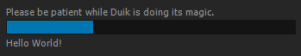
Duik.ui.progressPanel
Duik.ui.progressGroup
Duik.ui.progressBar
Duik.ui.progressStatus

Name | Type | Description
progressPanel | Window | Window containing the progress bar and status of libDuik
progressGroup | Group | The group in the Window progressPanel, used for the layout of child elements of the window.
progressBar | ProgressBar | The ProgressBar used by libDuik
progressStatus | StaticText | The text displayed behind the progressBar

Duik.ui Methods

Duik.ui.updateProgressPanel (val,status)
Duik.ui.showProgressPanel (maxVal,status)
Duik.ui.hideProgressPanel ()

Name | Description | Return
updateProgressPanel (val, status) | Updates the progress panel. | Void
showProgressPanel (maxVal, status) | Initializes and displays the progress panel. | Void
hideProgressPanel () | Hides the progress panel. | Void

Duik.ui.updateProgressPanel (val,status)

Updates the progress panel, setting the value of the progress bar and the text of the status.

parameters:

val | integer, the value of the progress bar
status | string, the text to display behind the progress bar

returns

void

Duik.ui. showProgressPanel (maxVal,status)

First, initializes the progress panel, settting the max value of the progress bar and the text to display behind it, then displays it.

parameters:

maxVal | integer, the max value of the progress bar
status | string, the text to display behind the progress bar

returns

void

Duik.ui. hideProgressPanel ()

Hides the progress panel.

returns

void
Duik.uiStrings

Contains all string names used by effects created by Duik.
You can set these strings to translate libDuik at runtime.
Default values are English names.

Duik.uiStrings Attributes

Duik.uiStrings.ik
Duik.uiStrings.wiggle
Duik.uiStrings.exposure
Duik.uiStrings.rotMorph
Duik.uiStrings.swing
Duik.uiStrings.wheel
Duik.uiStrings.lensFlare
Duik.uiStrings.distanceLink
Duik.uiStrings.spring
Duik.uiStrings.paintRig
Duik.uiStrings.flip
Duik.uiStrings.moveAway
Duik.uiStrings.multiplane
Duik.uiStrings.camInfluence

Name | Type | Default
ik | string | "IK"
wiggle | string | "Wiggle"
exposure | string | "Exposure"
rotMorph | string | "Rotation Morph"
swing | string | "Swing"
wheel | string | "Wheel"
lensFlare | string | "Lens Flare"
distanceLink | string | "Distance Link"
spring | string | "Spring"
paintRig | string | "Paint Rig"
flip | string | “Flip”
moveAway | string | "Distance from parent"
multiplane | string | "Multiplane"
camInfluence | string | "Camera Influence"

Duik.settings

Access to settings used by Duik.

Duik.settings Attributes

These attributes define some settings and preferences needed by Duik.
If you set them, they can be saved to be reloaded even if After Effects is shutdown, using Duik.settings.save(). If this method is not called, the settings will be set back to previous values if After Effects is shut down.
Saved settings must be loaded at runtime calling Duik.settings.load().
Default values can be restored using Duik.settings.restoreDefaults().

Duik.settings.controllerSize
Duik.settings.controllerType
Duik.settings.controllerSizeAuto
Duik.settings.controllerSizeHint
Duik.settings.boneType
Duik.settings.boneSize
Duik.settings.boneSizeAuto
Duik.settings.boneSizeHint
Duik.settings.boneColor
Duik.settings.morpherCreatesKeyframes
Duik.settings.getLayersMethod
Duik.settings.bonePlacement
Duik.settings.ctrlPlacement
Duik.settings.controllerColor

Name | Type | Description | Default
controllerSize | integer | Size of controllers in pixels | 100
controllerType | integer | Enumerated value, one of:  Duik.layerTypes.NULL  Duik.layerTypes.VECTOR | Duik.layerTypes.VECTOR
controllerSizeAuto | boolean | If true, controller sizes will be automatically adapted to comp size, according to Duik.settings.controllerSizeHint | true
controllerSizeHint | integer | Enumerated value, one of:  Duik.sizes.SMALL  Duik.sizes.MEDIUM  Duik.sizes.BIG | Duik.sizes.MEDIUM
boneType | integer | Enumerated value, one of:  Duik.layerTypes.NULL  Duik.layerTypes.SOLID | Duik.layerTypes.SOLID
boneSize | integer | Size of bones in pixels | 20
boneSizeAuto | boolean | If true, bone sizes will be automatically adapted to comp size, according to Duik.settings.boneSizeHint | true
boneSizeHint | integer | Enumerated value, one of:  Duik.sizes.SMALL  Duik.sizes.MEDIUM  Duik.sizes.BIG | Duik.sizes.MEDIUM
boneColor | string | Hex value of the color of the bones, excluding the leading « # » | « FF0000 »
morpherCreatesKeyframes | boolean | If true, morpher will automatically create keyframes for each keyframe of the controlled properties | True
getLayersMethod | boolean | The method used to get layers (i.e. when pasting an animation)  Enumerated value, one of:  Duik.getLayers.NAME  Duik.getLayers.INDEX  Duik.getLayers.SELECTION_INDEX | Duik.getLayers.NAME
bonePlacement | integer | The placement of the bones in the comp.  Enumerated value, one of:  Duik.placement.TOP  Duik.placement.BOTTOM  Duik.placement.OVER_LAYER  Duik.placement.UNDER_LAYER | Duik.placement.OVER_LAYER
ctrlPlacement | integer | The placement of the controllers in the comp.  Enumerated value, one of:  Duik.placement.TOP  Duik.placement.BOTTOM  Duik.placement.OVER_LAYER  Duik.placement.UNDER_LAYER | Duik.placement.TOP
controllerColor | Array of integer | The color of the controllers, [R,G,B,A] or one of:  Duik.colors.WHITE  Duik.colors.RED  Duik.colors.GREEN  Duik.colors.BLUE  Duik.colors.CYAN  Duik.colors.MAGENTA  Duik.colors.YELLOW  Duik.colors.BLACK  Duik.colors.LIGHT_GRAY  Duik.colors.DARK_GRAY | Duik.colors.WHITE  [1,1,1,1]

Duik.settings Methods

Duik.settings.save()
Duik.settings.load()
Duik.settings.restoreDefaults()

Name | Description | Return
save() | Saves Duik settings into After Effects preferences | void
load() | Loads Duik settings from After Effects preferences | void
restoreDefaults() | Restore default values to Duik settings | void

Duik.settings.save()

Saves Duik settings attributes into After Effects preferences (using app.settings.saveSetting())
Those settings can be loaded when the script runs using Duik.settings.load(). This allows to easily restore the settings set by the user even if After Effects is shut down.

parameters:

none

returns

void

Duik.settings.load()

Loads Duik settings attributes from After Effects preferences (using app.settings.getSetting())
This allows to easily restore the settings set by the user even if After Effects is shut down.
If this method is not called at runtime, default values will be loaded at first run.

parameters:

none

returns

void

Duik.settings.restoreDefaults()

Restore default values to Duik settings. These values will not be saved until Duik.settings.save() is called.

parameters:

none

returns

void

Duik.bridge

Tools for importing/exporting to/from After Effects.

Duik.bridge.tvPaint

Tools to import and export assets from/to TvPaint

Duik.bridge.tvPaint Methods

Duik.bridge.tvPaint.parseCam(camString)
Duik.bridge.tvPaint.loadCamFile(camFile)

Name | Description | Return
parseCam(camString) | Parses a string representing a camera exported from TVPaint. | TVPCamera object
loadCamFile(camFile) | Loads and parses a camera exported from TVPaint | TVPCamera object

Duik.bridge.tvPaint.parseCam(camString)

Parses a string representing a camera exported from TVPaint, with its animation.

parameters:

camString | the string to parse

returns

TVPCamera, see TVPCamera Object

Duik.bridge.tvPaint.loadCamFile(camFile)

Loads and parses a file representing a camera exported from TVPaint, with its animation.

parameters:

camFile | javascript File object to load

returns

TVPCamera, see TVPCamera Object

Duik.js

General javascript related tools.

Duik.js Methods

Duik.js.escapeRegExp(string)
Duik.js.replaceAll(string, find, replace, caseSensitive)
Duik.js.random(min, max)

Name | Description | Return
escapeRegExp(string) | Escapes all regular expressions special characters in the given string | string
replaceAll(string, find, replace, caseSensitive) | Replaces all occurences of find by replace in the given string | string
random(min, max) | Random number between min and max | float

Duik.js.escapeRegExp(string)

Escapes all regular expressions special characters in the given string.

parameters:

string | string

returns

string, the modified string.

Duik.js.replaceAll(string, find, replace, caseSensitive)

Replaces all occurences of find by replace in the given string.

parameters:

string | string to modify
find | string to search
replace | string, replacement
caseSensitive | boolean, wether to perform a caseSensitive search

returns

string, the modified string.

Duik.js.random(min, max)

Random number between min and max

parameters:

min | float or integer, the minimum value
max | float or integer, the maximum value

returns

float, the random number.
Duik.utils

Some useful methods.

Duik.utils Methods

Duik.utils.prepareProperty(property,isFX,index,depth,parentName)
Duik.utils.getPropertyDimensions(property)
Duik.utils.getLength(value1,value2)
Duik.utils.getAverageSpeed(layer,property)
Duik.utils.addPseudoEffect(layer,pseudoEffectName)
Duik.utils.getPuppetPins(effects)
Duik.utils.getDistance(layer1,layer2)
Duik.utils.rigProperty(layer,prop,pseudoEffect)
Duik.utils.deselectLayers()
Duik.utils.checkNames(comp)
Duik.utils.getItem(items, itemIndex)
Duik.utils.getKey(prop, keyIndex)
Duik.utils.getPropertyAnims(prop, selectedKeysOnly, startTime, endTime)
Duik.utils.getPropertyAnim(prop, selectedKeysOnly, startTime, endTime)
Duik.utils.setPropertyAnim(prop, propAnim, startTime)
Duik.utils.addKey(prop,key, startTime)
Duik.utils.getFirstKeyTime(prop)
Duik.utils.hasSelectedKeys(prop)
Duik.utils.convertCollectionToArray(collection)
Duik.utils.prepIK(layers)
Duik.utils.getControllers(layers)
Duik.utils.getAverageSpeeds(layers)
Duik.utils.replaceInExpressions(prop,oldString,newString)
Duik.utils.replaceInLayersExpressions(layers, oldString, newString)
Duik.utils.renameLayer(layer, newName, updateExpressions)
Duik.utils.renameItem(item, newName, updateExpressions)

Name | Description | Return
prepareProperty(property, isFX, index, depth, parentName) | Prepares property to be rigged | true if property can set expression, false otherwise
getPropertyDimensions(property ) | Gets the dimensions of the property (1, 2 or 3), taking care of 2D layer positions (reported as 3D by AFX, but to be considdered as 2D) | integer, number of dimensions
getLength(value1, value2) | Gets the length between the values, whichever dimensions they are | float, length between the values
getAverageSpeed(layer, property) | Gets the average speed of the animated property, between its first and last keyframe only | float, average speed of the property
addPseudoEffect(layer, pseudoEffectName) | Adds a Duik predefined pseudo effect to the layer | Property, the effect added
getDistance(layer1,layer2) | Measure distance between two layers | integer, distance between layers, in pixels
getPuppetPins(effects) | Gets all puppet pins from a layer effects | Array of Properties, all puppet pins found
rigProperty(layer, prop, pseudoEffect) | Performs some checks on the property and adds a pseudo effect on the layer | Property, the effect added
deselectLayers() | Deselects all layers | Void
checkNames(comp) | Checks for duplicate names among the layers of the comp, renaming them if found. | true if any layer was renamed
getItem(items, itemIndex) | Gets the item as if it were in a 0-based indexed Array, even if it is in a 1-based indexed Collection | Object, the item
getKey(prop, keyIndex) | Gets the keyframe at keyIndex on the property | KeyFrame object
getPropertyAnims(prop, selectedKeysOnly, startTime, endTime) | Gets the keyframe animations on the child properties of the prop, if it's a PropertyGroup (recursive), or the animation of the prop if it's a Property | Array of PropertyAnim objects
getPropertyAnim(prop, selectedKeysOnly, startTime, endTime) | Gets the keyframe animation of the Property | PropertyAnim object
setPropertyAnim(prop, propAnim, startTime) | Sets the animation on the property | boolean, true if succeeded
addKey(prop,key, startTime) | Adds a keyframe on the property | void
getFirstKeyTime(prop) | Gets the time of the first key on the property | float, time of the keyframe
hasSelectedKeys(prop) | Checks if the properties has keyframes which are selected | Boolean
convertCollectionToArray(collection) | Converts the given Collection to an array. If the parameter is already an Array, returns a copy of it. | Array
prepIK(layers) | Creates an IKRig object, automatically detecting each layer usage. | IKRig object
getControllers(layers) | Gets the controllers created by Duik found in the Array or Collection | Array of Controller objects
getAverageSpeeds(layers) | Gets the average variation speed of the selected properties in the layers | float, average speed
replaceInLayersExpressions(layers, oldString, newString) | Replaces all occurences of oldString by newString in all the expressions of all the layers. | void
renameLayer(layer, newName, updateExpressions) | Renames the layer, updating expressions in all the compositions of the project | void
renameItem(item, newName, updateExpressions) | Renames the item, updating expressions in all the compositions of the project, if the item is a CompItem | void

Duik.utils.prepareProperty(property,isFX,index,depth,parentName)

Prepare the given property to be rigged.
isFX, index, depth, parentName will be filled by the method with the values corresponding to this property.

parameters:

property | Property
isFX | boolean
index | integer
depth | integer
parentName | string

returns

true if property can set expression, false otherwise

Duik.utils.getPropertyDimensions(property)

Gets the dimensions of the property (1, 2 or 3), taking care of 2D layer positions (reported as 3D by AFX, but to be considdered as 2D)

parameters:

property | Property

returns

integer, number of dimensions

Duik.utils.getLength(value1, value2)

Gets the length between the values, whichever dimensions they are

parameters:

value1 | float or Array of float, first coordinates
value1 | float or Array of float, second coordinates

returns

float, length between the values

Duik.utils.getAverageSpeed(layer, property)

Gets the average speed of the animated property, between its first and last keyframe only.

parameters:

layer | AVLayer of the property
property | Property

returns

float, average speed of the property

Duik.utils.addPseudoEffect(layer, pseudoEffectFileName)

Adds a Duik predefined pseudo effect to the layer. The AFX preset file of the pseudo effect must be located in the same folder as libDuik.jsxinc and called « Duik_ » + pseudoEffectName + « .ffx ».
In the preset, the effect must be called pseudoEffectName.

parameters:

layer | AVLayer
pseudoEffectFileName | string, name of the file of the pseudo effect

returns

Property, the effect added

Duik.utils.getPuppetPins(effects)

Recursive method to find all puppet pins on a given layer, even if there is more than one puppet effect. You must provide the effects PropertyGroup of the layer.
Example : var pins = Duik.utils.getPuppetPins(app.project.activeItem.layer(1)(« Effects »);

parameters:

effects | PropertyGroup, the effects group of a layer

returns

Array of Property, the puppet pins

Duik.utils.getDistance(layer1,layer2)

Measures distance between two layers, in pixels.

parameters:

layer1 | AVLayer
layer2 | AVLayer

returns

integer, distance in pixels

Duik.utils.rigProperty(layer, prop, pseudoEffect)

Performs some checks on the property and adds a pseudo effect on the layer.
The AFX preset file of the pseudo effect must be located in the same folder as libDuik.jsxinc and called « Duik_ » + pseudoEffectName + « .ffx ».
In the preset, the effect must be called pseudoEffectName.

parameters:

layer | AVLayer
prop | Property
pseudoEffect | file name of the pseudo effect

returns

PropertyGroup, the effect added

Duik.utils.deselectLayers()

Deselects all layers

returns

void

Duik.utils.checkNames(comp)

Checks for duplicate names among the layers of the comp, renaming them if found. This method is called everytime libDuik creates an effect which involves expressions and more than one layer, to avoid any bug with expressions linking to wrong layers.

parameters:

comp | CompItem where are the layers which must be checked. Default: app.project.activeItem

returns

true if any layer was renamed, false otherwise.

Duik.utils.getItem(items, itemIndex)

After effects sometimes uses its own Collection class, which is very similar to Arrays, but the first element of a Collection is at index 1 instead of 0 as in an Array.
This can make it difficult to write functions which will work both on Array or Collections.
Example:

function doSomethingOnLayers(layers) {
for (i = 0 ; i < layers.length ; i++) {
var layer = layers[i];
//do something
}
}

//will work correctly, as selectedLayers is an Array beginning at index 0
doSomethingOnLayers(app.project.activeItem.selectedLayers);

//will not work, as layers is a LayerCollection beginning at index 1
doSomethingOnLayers(app.project.activeItem.layers);

This method makes it possible to get an item both for an Array or a Collection, without knowing which type is given.

function doSomethingOnLayers(layers) {
for (i = 0 ; i < layers.length ; i++) {
var layer = Duik.utils.getItem(layers,i);
//do something
}
}

//both will work correctly
doSomethingOnLayers(app.project.activeItem.selectedLayers);
doSomethingOnLayers(app.project.activeItem.layers);

parameters:

items | Array or Collection
itemIndex | int, index where the item must be found

returns

Object, the item at itemIndex in items.

Duik.utils.getKey(prop, keyIndex)

Gets the keyframe at keyIndex on the property
see KeyFrame object

parameters:

prop | Property
keyIndex | int

returns

KeyFrame object

Duik.utils.getPropertyAnims(prop, selectedKeysOnly, startTime, endTime)

Gets the keyframe animations on the child properties of the prop, if it's a PropertyGroup (recursive), or the animation of the prop if it's a Property, beginning at startTime and ending at endTime.
This is a recursive method.
see PropertyAnim object

parameters:

prop | PropertyBase
selectedKeysOnly | boolean
startTime | float
endTime | float

returns

Array of PropertyAnim objects

Duik.utils.getPropertyAnim(prop, selectedKeysOnly, startTime, endTime)

Gets the keyframe animation of the Property
This is not a recursive method (it won't check child properties); see Duik.utils.getPropertyAnims() for the recursive method.
see PropertyAnim object

parameters:

prop | Property
selectedKeysOnly | boolean
startTime | float
endTime | float

returns

PropertyAnim object

Duik.utils.setPropertyAnim(prop, propAnim, startTime)

Sets the animation on the property, beginning at startTime
see PropertyAnim object

parameters:

prop | PropertyBase
propAnim | PropertyAnim object
startTime | float

returns

boolean, true if succeeded.

Duik.utils.addKey(prop,key, startTime)

Adds a keyframe on the property. You can offset the time by setting startTime
see KeyFrame object

parameters:

prop | PropertyBase
key | KeyFrame object
startTime | float, default: 0

returns

void

Duik.utils.getFirstKeyTime(prop)

Gets the time of the first key on the property.

parameters:

prop | Property

returns

float

Duik.utils.hasSelectedKeys(prop)

Checks if the properties has keyframes which are selected.

parameters:

prop | Property

returns

boolean

Duik.utils.convertCollectionToArray(collection)

Converts the given Collection to an array. If the parameter is already an Array, returns a copy of it.

parameters:

collection | Collection or Array

returns

Array

Duik.utils.prepIK(layers)

Creates an IKRig object, automatically detecting each layer usage.
The detection checks the hierarchy of the layers to find each layer usage.
If the detection fails, the IKRig object is created using the order of the layers in the Array or LayerCollection: the first are the layers, beginning by the last child, the last one is the controller.
Goal layers are detected by measuring the distance between the last child of the chain and the controller: goal layers and controllers should be at the same place.
See IKRig object.

parameters:

layers | Array of AVLayers or LayerCollection

returns

IKRig object

Duik.utils.getControllers(layers)

Gets the controllers created by Duik found in the Array or LayerCollection. If the Array or the LayerCollection are empty, or if not provided, gets the controllers found in the active comp.
See Controller object.

parameters:

layers | Array of AVLayers or LayerCollection

returns

Array of Controller objects.

Duik.utils.getAverageSpeed(layers)

Gets the average variation speed of the selected properties in the layers.

parameters:

layers | Array of AVLayers or LayerCollection

returns

float, the average speed.

Duik.utils.replaceInLayersExpressions(layers, oldString, newString)

Replaces all occurences of oldString by newString in all the expressions of all the layers.

parameters

layers | Array of AVLayers or LayerCollection
oldString | string
newString | string

returns

void

Duik.utils.renameLayer(layer, newName, updateExpressions)

Renames the layer, updating expressions in all the compositions of the project.

parameters

layer | Layer
newName | string
updateExpressions | boolean, default: true

returns

void

Duik.utils.renameItem(item, newName, updateExpressions)

Renames the item, updating expressions in all the compositions of the project if the item is a CompItem

parameters

item | Item
newName | string
updateExpressions | boolean, default: true

returns

void

